存储过程和函数

1. 存储过程和函数：

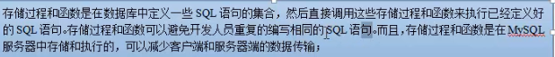

1. 创建存储过程：



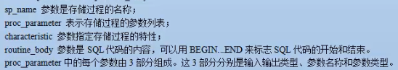

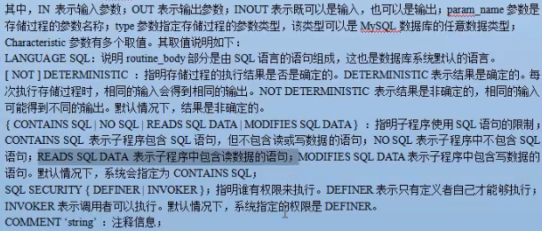

DELIMITER &&

CREATE PROCEDURE proc(IN i INT,OUT o VARCHAR(199))

READS SQL DATA

BEGIN

SELECT COUNT(*) AS sumsun FROM t_book WHERE bookTypeId = i;

END

&&

DELIMITER ;

调用存储过程：CALL proc(3,@total)

1. 创建函数：

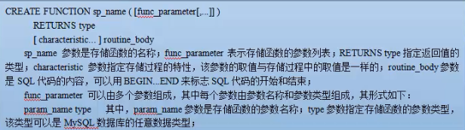

创建函数：

DELIMITER &&

CREATE FUNCTION func(ids INT)

RETURNS VARCHAR(188)

BEGIN

RETURN (SELECT bookName FROM t_book WHERE id = ids);

END

&&

DELIMITER ;

**调用函数：SELECT func(2);**

1. 变量的使用：

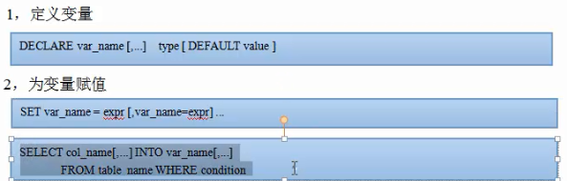

例子：

DELIMITER &&

CREATE PROCEDURE pro2()

BEGIN

DECLARE a,b VARCHAR(20);

SET a = 'abcd',b = 'efgh';

INSERT INTO usertable VALUES(NULL,a,b);

END

&&

DELIMITER ;

**调用存储过程CALL pro2();**

**例子2**

**DELIMITER &&**

**CREATE PROCEDURE pro3()**

**BEGIN**

**DECLARE a,b VARCHAR(20);**

**SELECT name1,password2 INTO a,b FROM usertable WHERE id=5;//把id为5的一行的相应值赋给变量ab**

**INSERT INTO usertable VALUES(NULL,a,b);**

**END**

**&&**

**DELIMITER ;**

**CALL pro3();**

1. 游标的使用：

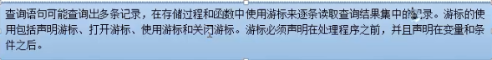

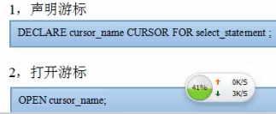

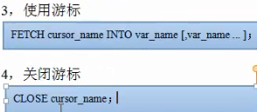

1. 流程控制的使用：



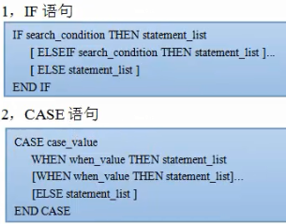

例如：DELIMITER &&

CREATE PROCEDURE proc2(IN ii INT)

BEGIN

SELECT COUNT(*) INTO @num FROM t_book WHERE bookTypeId = ii;

IF @num > 1 THEN UPDATE t_book SET bookName = '山东科技大学' WHERE bookTypeId = ii;

ELSE

INSERT INTO t_book VALUES(NULL,'北京邮电大学',67,'lata',2);

END IF;

END

&&

DELIMITER ;

CALL proc2(2);

示例2

DELIMITER &&

CREATE PROCEDURE proc3(IN ii INT)

BEGIN

SELECT COUNT(*) INTO @num FROM t_book WHERE bookTypeId = ii;

CASE @num

WHEN 1 THEN UPDATE t_book SET bookName = '山东科技大学' WHERE bookTypeId = ii;

ELSE INSERT INTO t_book VALUES(NULL,'北京邮电大学',67,'lata',2);

END CASE;

END

&&

DELIMITER ;

**CALL proc3(1);**

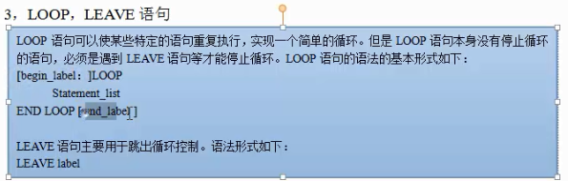

DELIMITER &&

CREATE PROCEDURE proc4(IN number INT)

BEGIN

aaa:LOOP

SET number = number - 1;

INSERT INTO t_book VALUES(NULL,'北京邮电大学',67,'lata',2);

IF number < 0 THEN LEAVE aaa;

END IF;

END LOOP aaa;

END

&&

DELIMITER ;

CALL proc4(12);

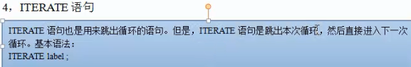

**iterate类似continue，leave相当于break。**

DELIMITER &&

CREATE PROCEDURE proc5(IN number INT)

BEGIN

aaa:LOOP

SET number = number - 1;

IF number > 3 THEN IF number = 5 THEN ITERATE aaa;END IF;

ELSE LEAVE aaa;

END IF;

INSERT INTO t_book VALUES(NULL,'北京邮电大学',67,'lata',2);

END LOOP aaa;

END

&&

DELIMITER ;

CALL proc5(12);

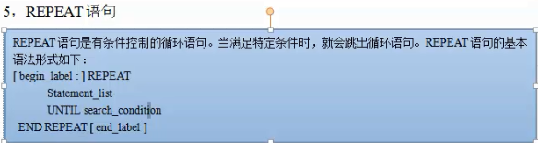

DELIMITER &&

CREATE PROCEDURE proc7(IN number INT)

BEGIN

REPEAT

SET number = number-1;

INSERT t_book VALUES(NULL,'北京邮电大学',67,'lata',2);

UNTIL number=0

END REPEAT;

END

&&

DELIMITER ;

CALL proc7(2);

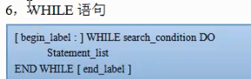

DELIMITER &&

CREATE PROCEDURE proc8(IN number INT)

BEGIN

WHILE number > 0 DO

SET number = number -1;

INSERT INTO t_book VALUES(NULL,'北京邮电大学',67,'lata',2);

END WHILE ;

END

&&

DELIMITER ;

CALL proc8(4);

1. 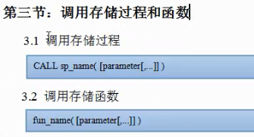

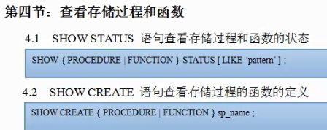



SHOW PROCEDURE STATUS LIKE 'pro'  
